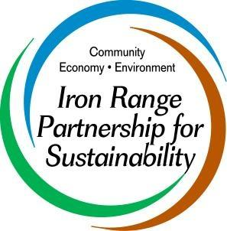
“IRPS facilitates collaboration towards a sustainable and thriving Iron Range.”

Iron Range Partnership for Sustainably Board of Directors Nomination Form

(****To be filled out by IRPS Board Member****)

Nominee’s Name:

Employer & Title:

Address:

City: State: Zip Code:

Phone (#1): Phone (#2):

E-mail (#1): E-mail (#2):

Describe skills, talents, and affiliations of the nominee

(IMPORTANT: Consider whether they bring continuity or access to new or a variety of networks in the community. The IRPS board desires diversity in membership. Attach Additional page if needed.)

Why are you recommending this person?

Nominator’s Name:

Date:

*Please complete and return to next IRPS board meeting

Revised 2/19/2018

